**MEASURE ENERGY CONSUMPTION USING PYTHON**

**TEAM MEMBER**

**731721106017:V.Saranya**

**Phase 4 Submission Document**

**Project: Measure Energy Consumption**

**Introduction:**

* Provide an overview of the project, highlighting the significance of energy conservation in residential and commercial buildings.

* Explain the challenges faced in accurately measuring and analyzing energy consumption.

* Introduce the AI-based solution as a means to tackle these challenges effectively

Steps:

1. Data Collection: Gather comprehensive data on energy consumption, including electricity, gas, and water usage, from various sensors and meters installed in buildings.

2. Data Preprocessing: Clean and preprocess the collected data, handling missing values, outliers, and ensuring data consistency.

3. Feature Engineering: Create meaningful features from the raw data, such as daily, weekly, and monthly energy usage patterns, weather conditions, and occupancy information.

DataSource: https://colab.research.google.com/drive/1FbJekYE3fErY5TZinhhK9dE-b-uOjZAU?usp=sharing

**Data source;**

<https://colab.research.google.com/drive/12n66qEvUla79jg9JH2ogI9PgeqXbzq2S?usp=sharing>

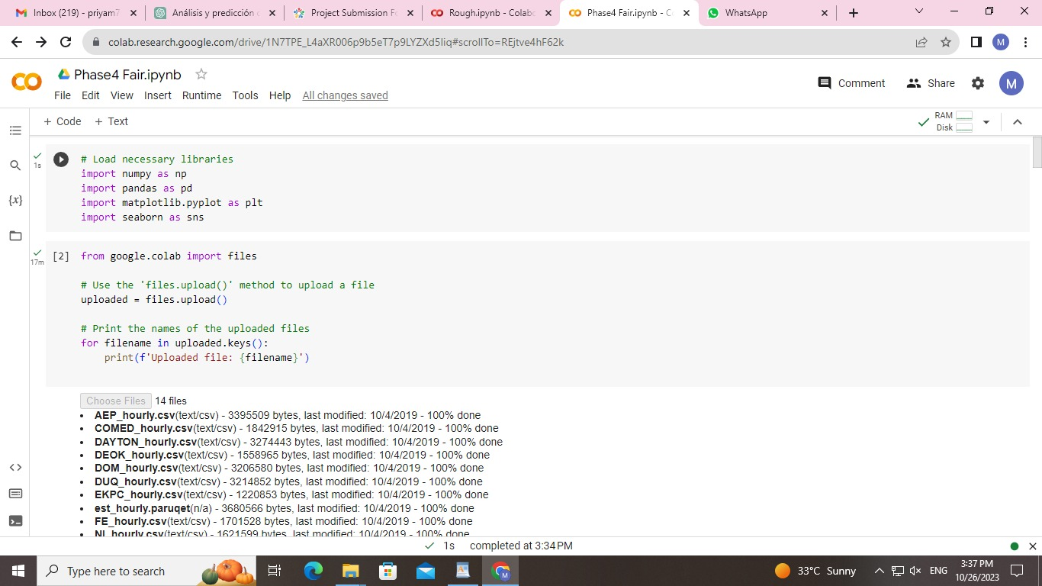

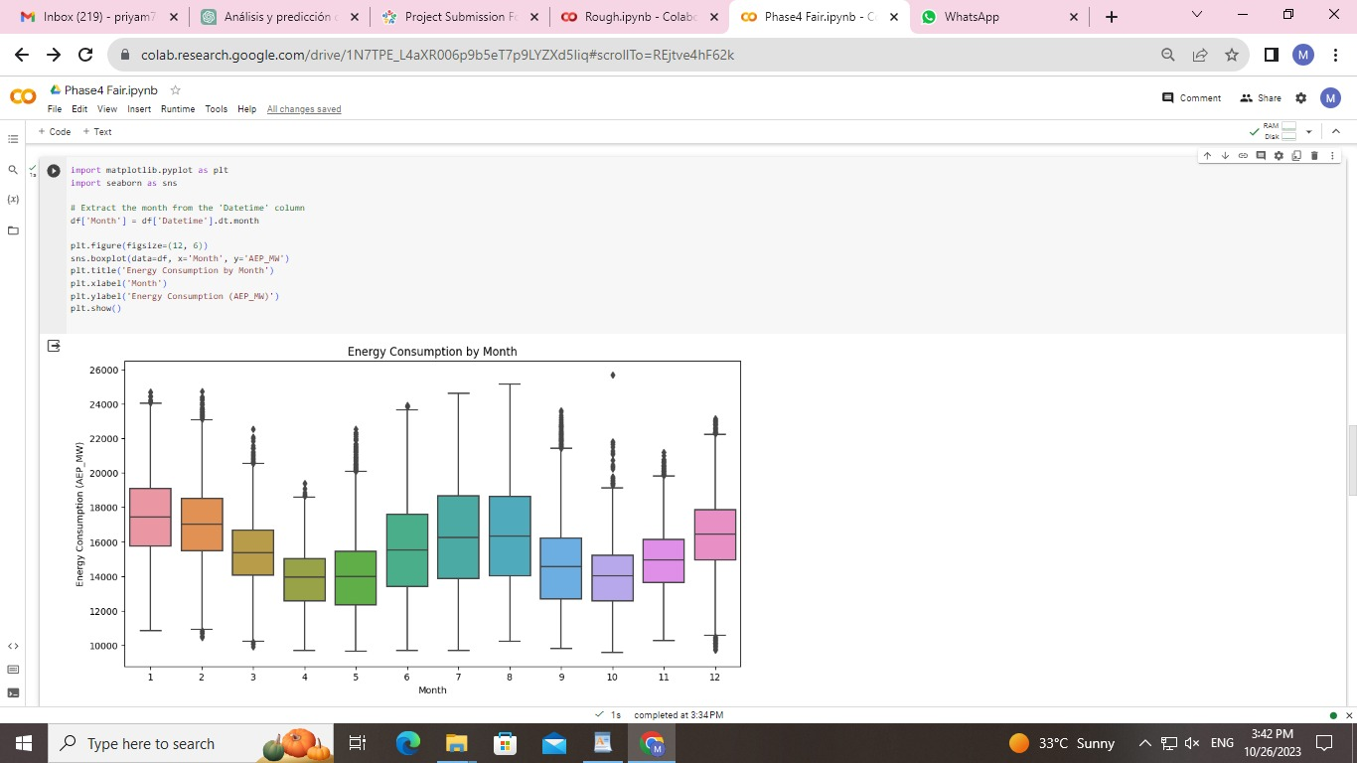

**Dataset Link:**[**https://www.kaggle.com/datasets/robikscube/hourly-energy-consumption**](https://www.kaggle.com/datasets/robikscube/hourly-energy-consumption)